# ABC Inventory Management

# Test Scenario: UAT Scenario 2

Table of Contents

ABC Inventory Management 1

Test Scenario: UAT Scenario 2 1

Scenario Description 4

Version Control 4

Test Scripts 4

Use Case 4

Test Components/ Requirements 4

User Groups 4

Test Scripts 4

AS001: Add Staff Script 4

Script Description 4

Testing Requirements 5

Setup 5

Teardown 5

Script Steps 5

Result Screenshots 5

AP001: Add Product Script 9

Script Description 9

Testing Requirements 9

Setup 9

Teardown 9

Script Steps 10

Result Screenshots 10

EP001: Edit Product Script 16

Script Description 16

Testing Requirements 16

Setup 16

Teardown 16

Script Steps 16

Result Screenshots 16

EPQ001: Edit Product Quantity Script 19

Script Description 19

Testing Requirements 19

Setup 19

Teardown 19

Script Steps 20

Result Screenshots 20

Test Execution 24

# Scenario Description

This scenario is intended to test a business condition when a Warehouse Staff must add a new staff to the system that starts work soon at the Warehouse. The new warehouse staff then must log in to the system and add a new product, edit an existing product and edit the product quantity of an already existing product in Store 1.

# Version Control

|  |  |  |  |
| --- | --- | --- | --- |
| Version Number | Date | Author | Description |
| 5.0 | 18/09/2018 | Shirish Maharjan | Initial Draft |
| 5.1 | 19/09/2018 | Shirish Maharjan | First Version (Iteration 5) |

# Test Scripts

The following are the test scripts that will cover this scenario:

* AS001 Add Staff Script
* APS001 Add Product Script
* EP001 Edit Product Script
* EPQ001 Edit Product Quantity Script

# Use Case

The use case covered by this test scenario is as follows:

* Manage Product
* Manage Staff

# Test Components/ Requirements

This test scenario covers the following high-level testing requirements:

* Manage Product Functionality of the system
* Manage Staff Functionality of the system

# User Groups

* Warehouse Staff

# Test Scripts

The following are the elaboration of the test script mentioned above:

# AS001: Add Staff Script

## Script Description

This script follows each step while adding a new staff to the system by a Warehouse Staff. This script will check if each step while adding a new staff into the system is a success. If any step fails to succeed, a bug will be reported, and the test will be conducted again.

## Testing Requirements

This test will cover the Manage Staff functionality of the system.

## Setup

* The computer in the location is powered on.
* Make sure the computer is connected to the internet.
* Application is launched.
* Warehouse Staff username and password are known.
* New staff is hired in warehouse.

## Teardown

* New staff is added who can login to the system

## Script Steps

|  |  |  |  |
| --- | --- | --- | --- |
| Step | Test Action | Expected Results | Pass/Fail |
| 1. | Application is launched. | System displays the ‘Login’ Page with the Username and Password field empty. | Pass |
| 2. | Warehouse staff enters username and password in the username and password field. | System waits till user to click on ‘Login’ button. | Pass |
| 3. | Click on the ‘Login’ button. | System grants access to the user and opens the Homepage. | Pass |
| 4. | Click on ‘Manage Staff’ button in homepage. | System displays the ‘Manage Staff’ page and wait for user’s action. | Pass |
| 5. | Click on ‘Add New Staff’ button. | System displays the ‘Add new Staff’ page and waits for user’s action. | Pass |
| 6. | Enter new staff details. | System waits for user’s action. | Pass |
| 7. | Click on ‘Add’ button. | System displays a message saying new staff is added. | Pass |

### Result Screenshots

**Step 1**

Application launched, and login page is displayed.

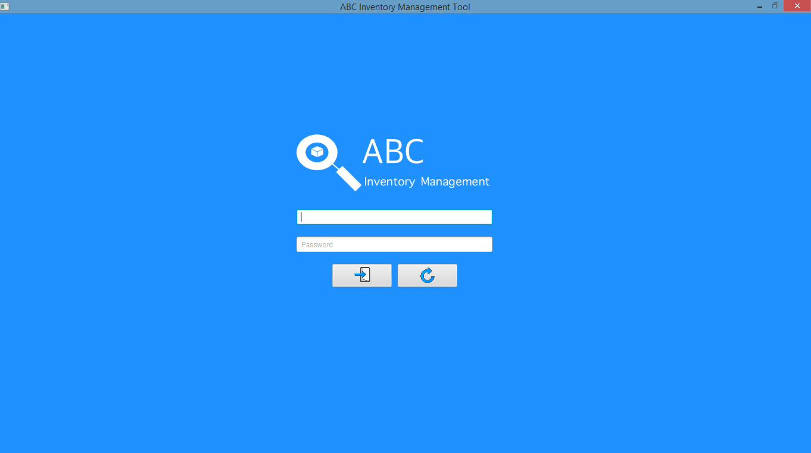

**Step 2**

Username and password are entered, and the system waits user to click on the ‘Login’ button.

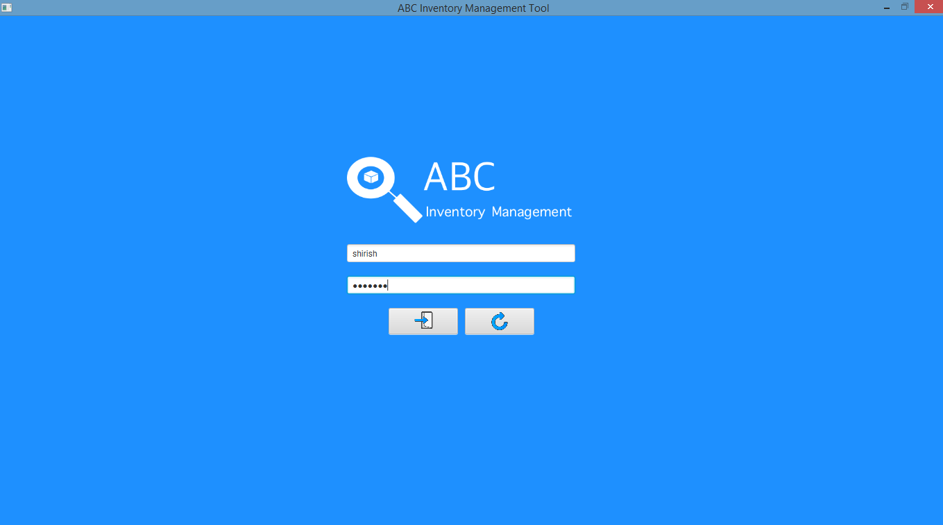

**Step 3**

After the ‘Login’ button is pressed at step 2, access is granted, and the Homepage is displayed.

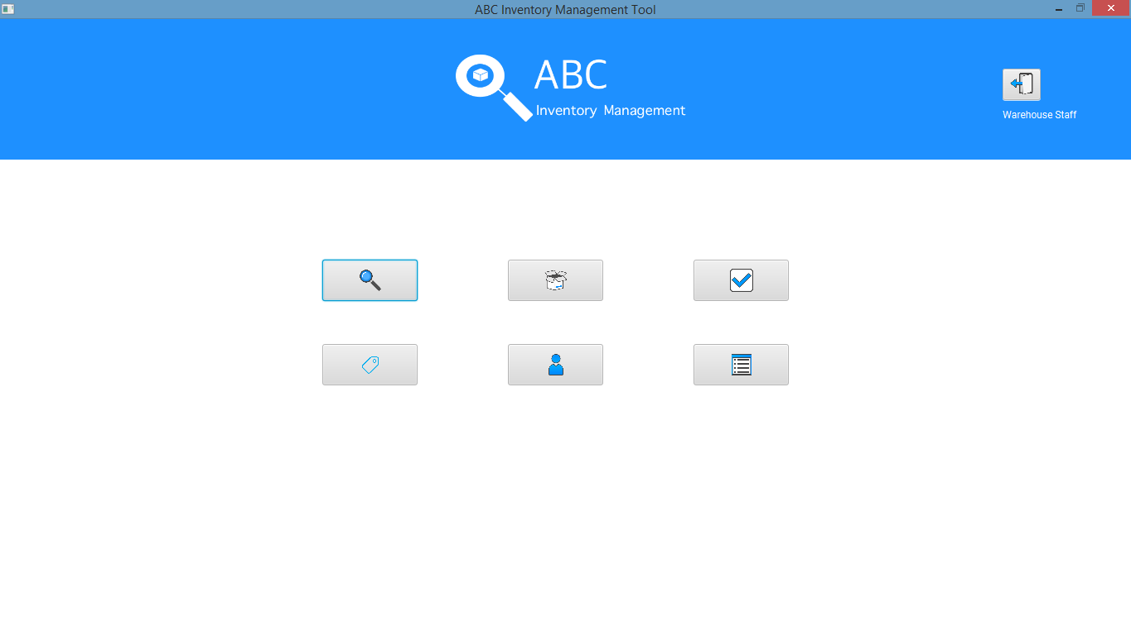

**Step 4**

After ‘Manage Staff’ button is clicked at Homepage, Manage Staff page is displayed.

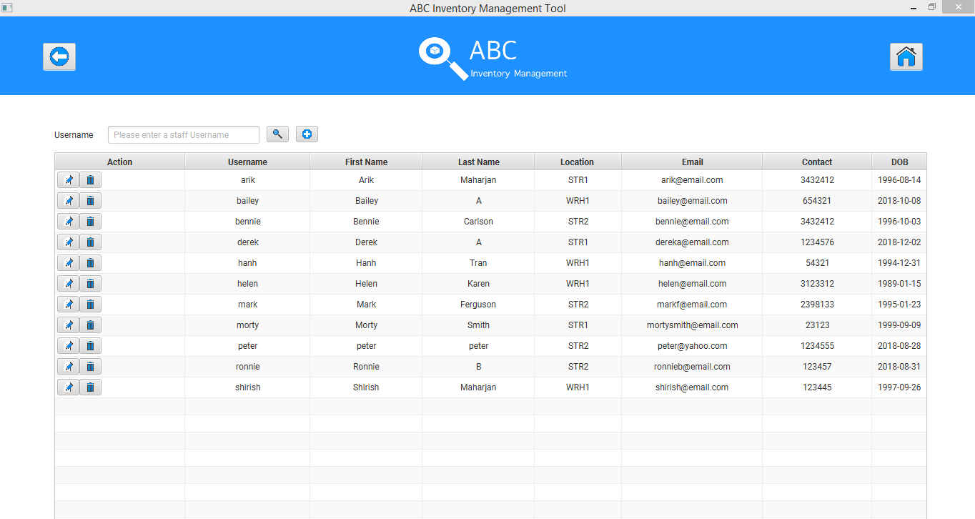

**Step 5**

After clicking on the ‘Add Staff’ button, add staff page is displayed.

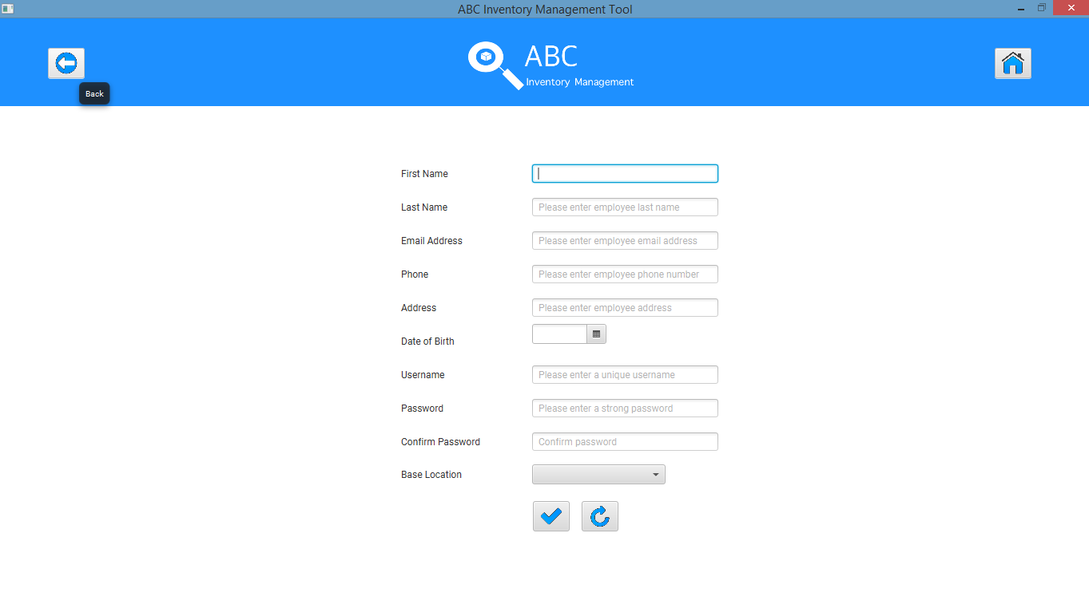

**Step 6**

Enter details of the new staff and assign the staff to ‘Newtown Warehouse’ (Where the new staff is hired) and click on ‘Add’ icon.

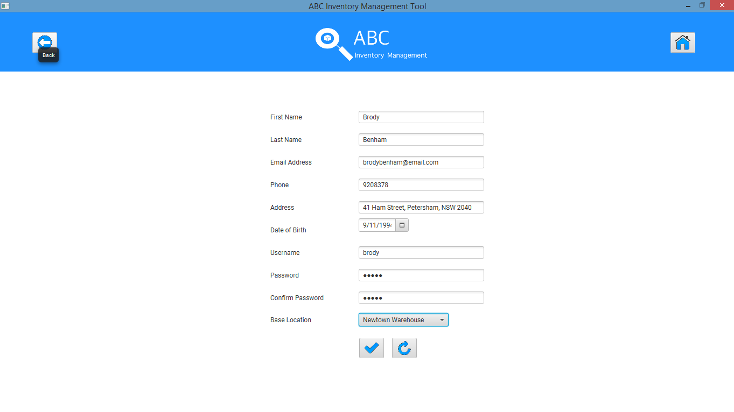

**Step 7**

A message is displayed saying the new staff is added to the system.

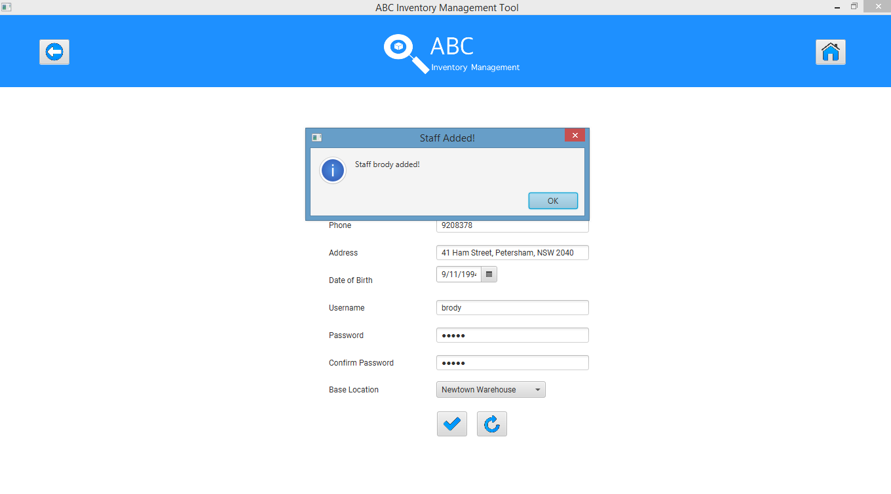

# AP001: Add Product Script

## Script Description

This script follows each step while adding a new product to the system by a Warehouse Staff that was added in AS001. This script will check if each step while adding a new product into the system is a success. If any step fails to succeed, a bug will be reported, and the test will be conducted again.

## Testing Requirements

This test will cover the Manage Product functionality of the system.

## Setup

* The computer in the location is powered on.
* Make sure the computer is connected to the internet.
* Application is launched.
* Warehouse Staff username and password are known.
* New product is launched of which a size XS with quantity 10 needs to be added to the Warehouse.

## Teardown

* New product is added to the system.

## Script Steps

|  |  |  |  |
| --- | --- | --- | --- |
| Step | Test Action | Expected Results | Pass/Fail |
| 1. | Application is launched. | System displays the ‘Login’ Page with the Username and Password field empty. | Pass |
| 2. | Warehouse staff enters username and password in the username and password field. | System waits till user to click on ‘Login’ button. | Pass |
| 3. | Click on the ‘Login’ button. | System grants access to the user and opens the Homepage. | Pass |
| 4. | Click on ‘Manage Product’ button in homepage. | System displays the ‘Manage Product’ page and wait for user’s action. | Pass |
| 5. | Click on ‘Add New Product’ button. | System displays the ‘Add New Product’ page and waits for user’s action. | Pass |
| 6. | Enter new product details. Details about the new product is provided by the marketing department. | System waits for user’s action. | Pass |
| 7. | Click on ‘Add’ button. | System displays a message saying new product is added. | Pass |
| 8. | Click on ‘Ok’. | System displays ‘Add Product Item’ page. | Pass |
| 9. | Select size XS allocating 10 of it to Newtown Warehouse. | System waits for user’s action. | Pass |
| 10. | Click on ‘Add’ button. | System displays a message saying the product in size XS has been allocated to the Warehouse. | Pass |

### Result Screenshots

**Step 1**

Application launched, and login page is displayed.

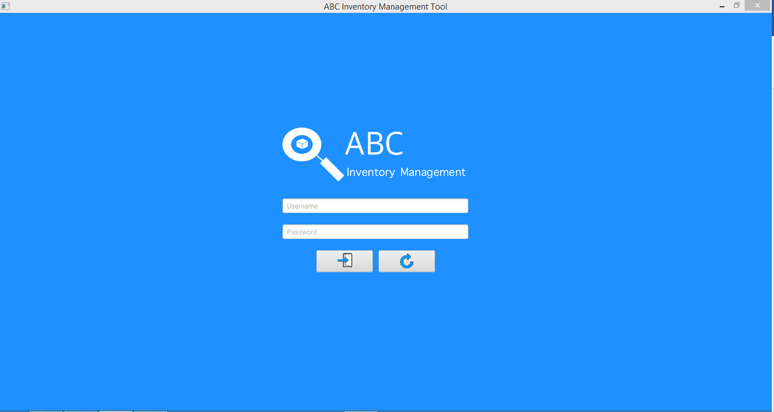

**Step 2**

Username and password are entered, and the system waits user to click on the ‘Login’ button.

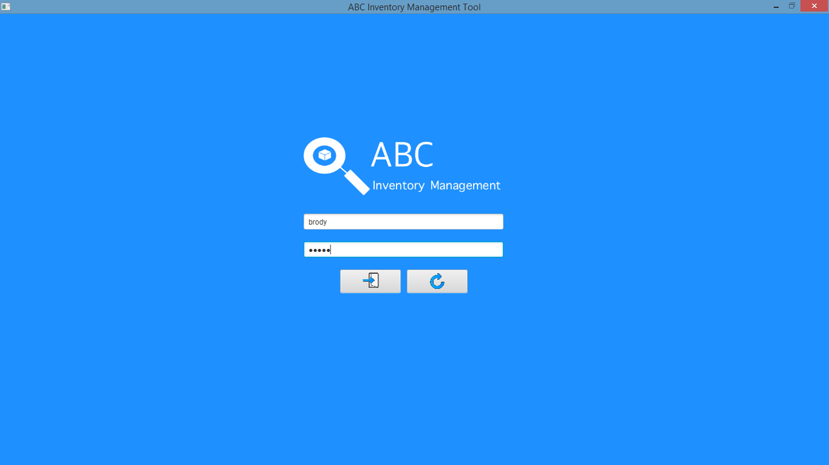

**Step 3**

After the ‘Login’ button is pressed at step 2, access is granted, and the Homepage is displayed.

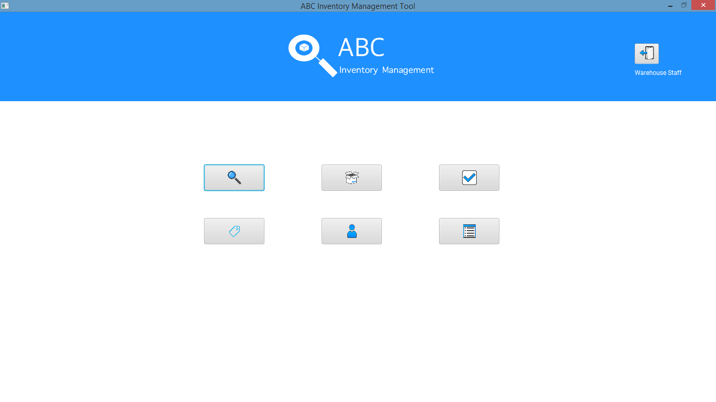

**Step 4**

After the ‘Manage Product’ button is clicked at homepage, Manage Product page is displayed.

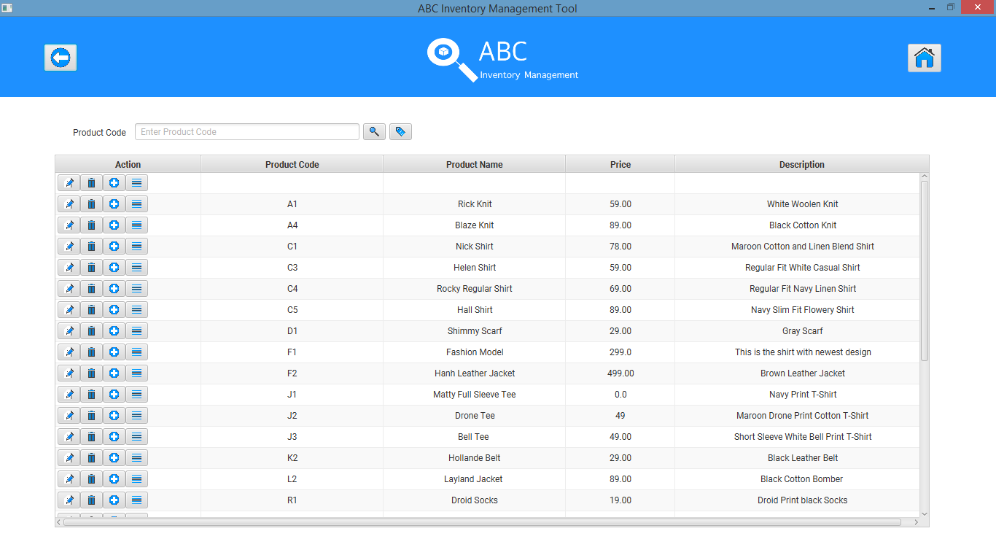

**Step 5**

After user clicks on the ‘Add New Product’ icon, Add Product page is displayed.

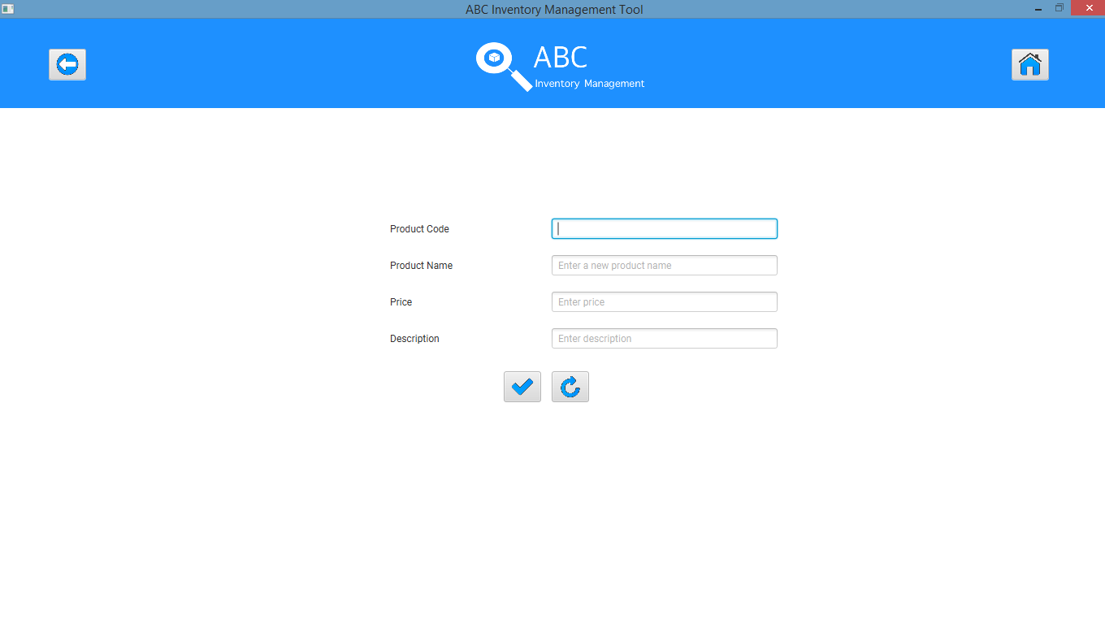

**Step 6**

User enters the details of the new product which is about to be launched of which 10 XS is in the warehouse. Details about the new product is provided by the marketing department.

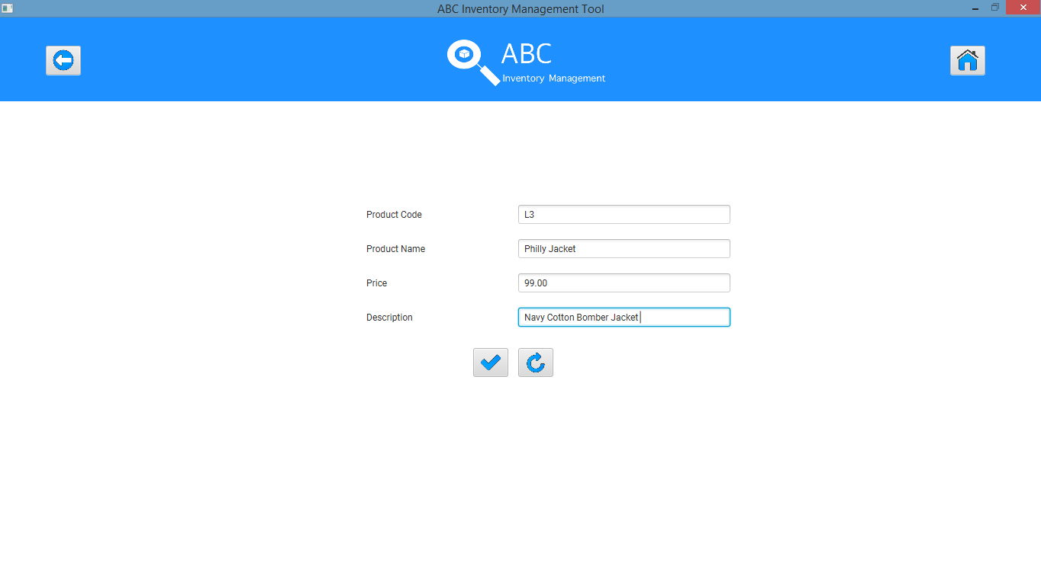

**Step 7**

After clicking on ‘Add’ icon, system displays a message saying the product has been added.

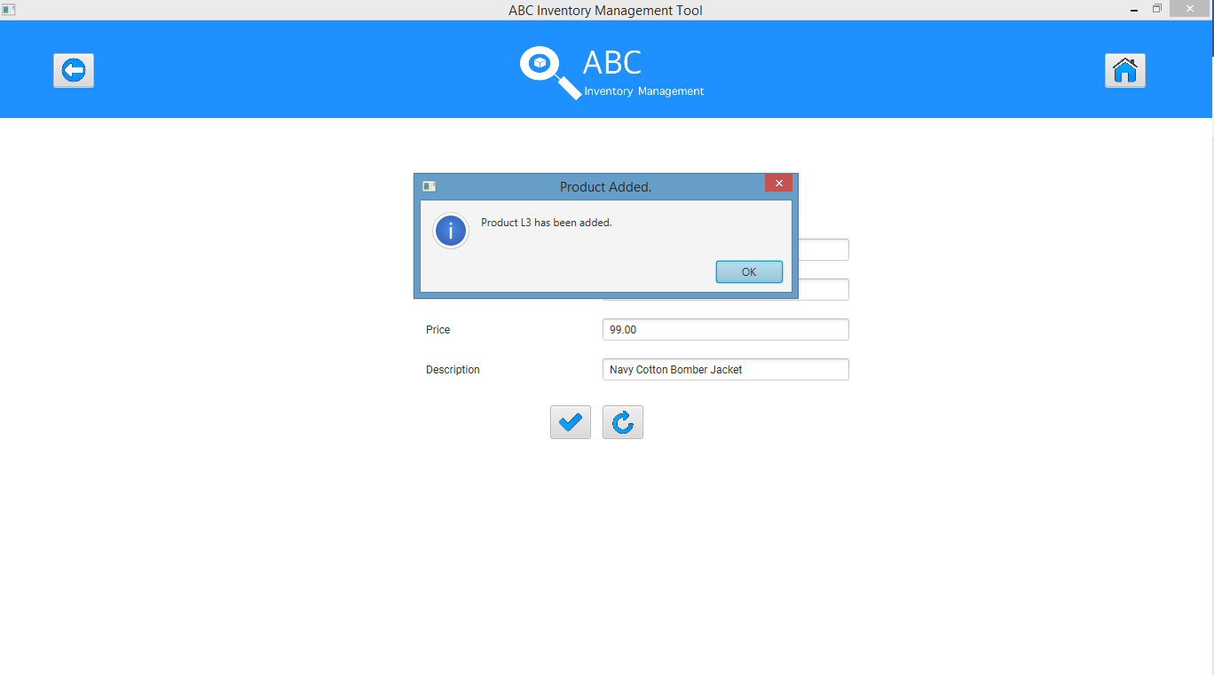

**Step 8**

Add new product item (adding a size and allocating it to particular location) page is displayed.

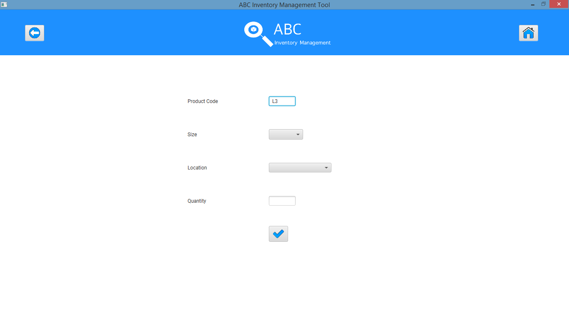

**Step 9**

Product Code cannot be changed in this page. ‘XS’ is selected as size, ‘Newtown Warehouse’ is selected as the location and quantity is entered as 10.

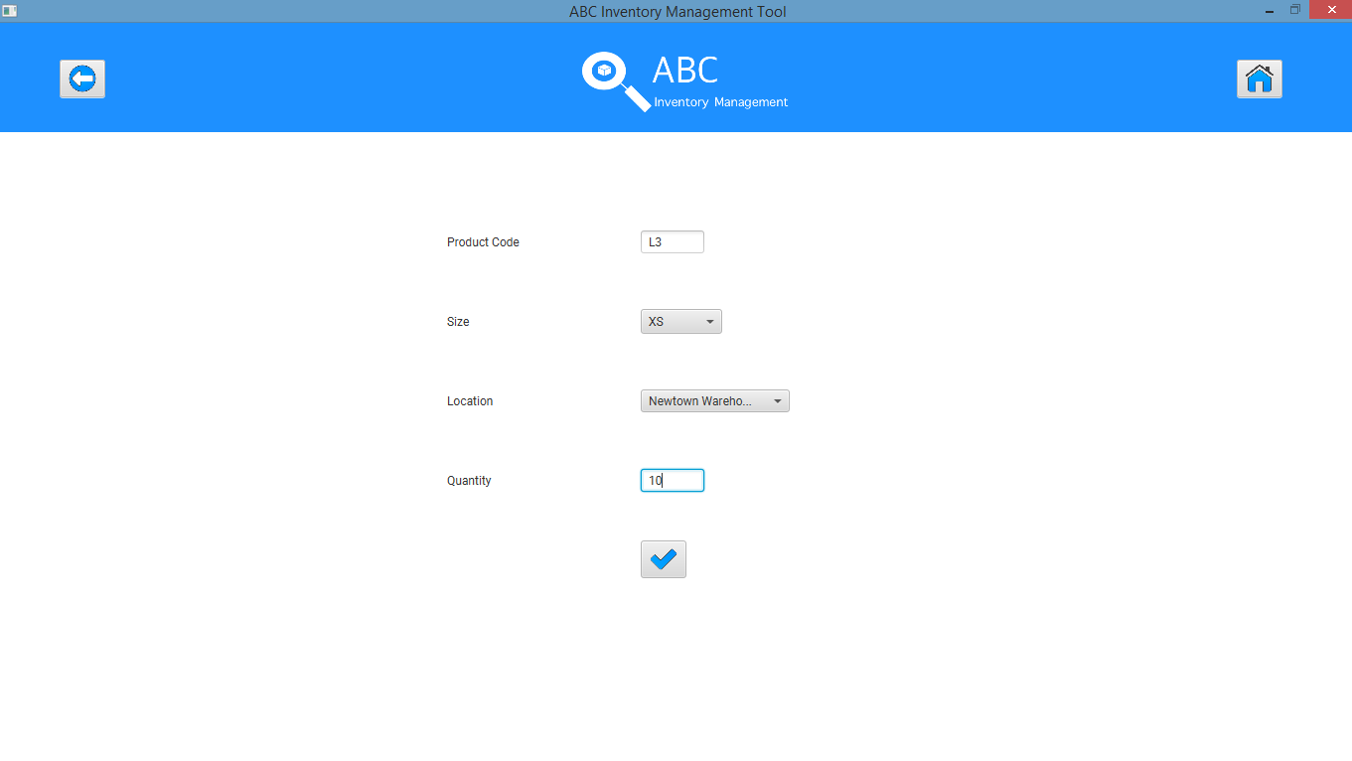

**Step 10**After clicking on the ‘Add’ icon, system displays a message saying the size has been added to the allocated location.

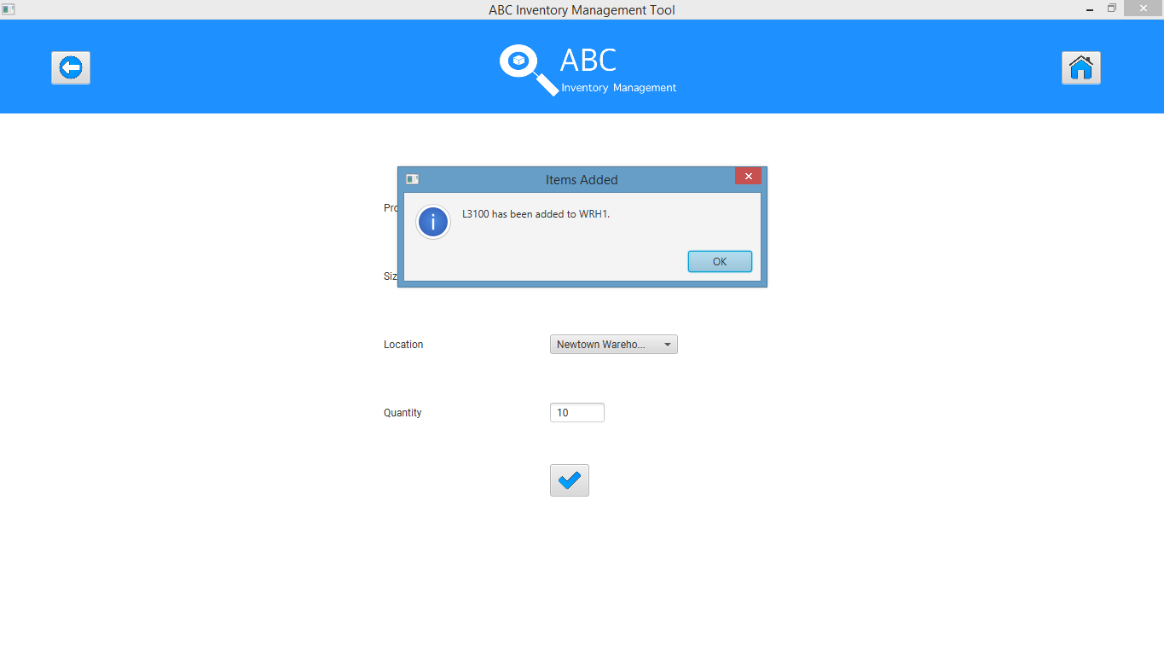

# EP001: Edit Product Script

## Script Description

This script follows each step while editing a product in the system that was added in AP001. The script will assume that the name of the product added in AP001 needs to be edited. This script will check if each step while editing a product is a success. If any step fails to succeed, a bug will be reported, and the test will be conducted again.

## Testing Requirements

This test will cover the Manage Product functionality of the system.

## Setup

* The computer in the location is powered on.
* Make sure the computer is connected to the internet.
* Application is launched.
* Warehouse Staff username and password are known.
* Product that needs to be edited exists.

## Teardown

* Product is edited.

## Script Steps

|  |  |  |  |
| --- | --- | --- | --- |
| Step | Test Action | Expected Results | Pass/Fail |
|  | Click on ‘Manage Product’ button in homepage. | System displays the ‘Manage Product’ page and wait for user’s action. | Pass |
|  | Search for the product that needs to be edited using the product code ‘L3’ | System displays details of the product ‘L3’ | Pass |
|  | Click on ‘Edit’ icon. | System displays the edit product page with the current details of the product which is editable except for the product code which cannot be changed. | Pass |
|  | Change the details as required. | System waits for user’s action. | Pass |
|  | Click on ‘Update’. | System displays a message saying the product is updated. | Pass |

### Result Screenshots

**Step 1**

After clicking on ‘Manage Product’ at homepage.

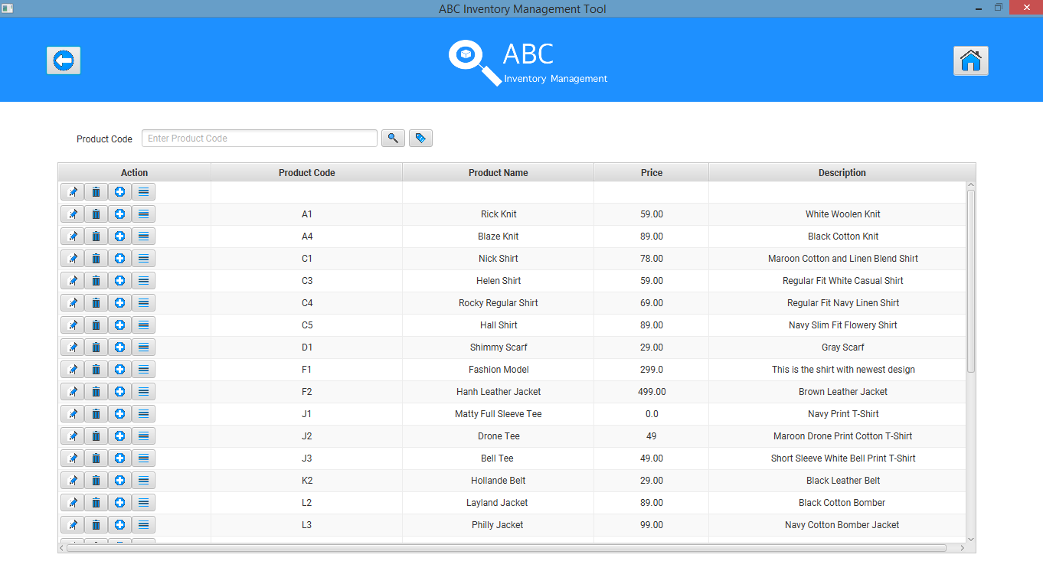

**Step 2**

Search for the product ‘L3’ which needs to be updated using the search feature in Manage Product.

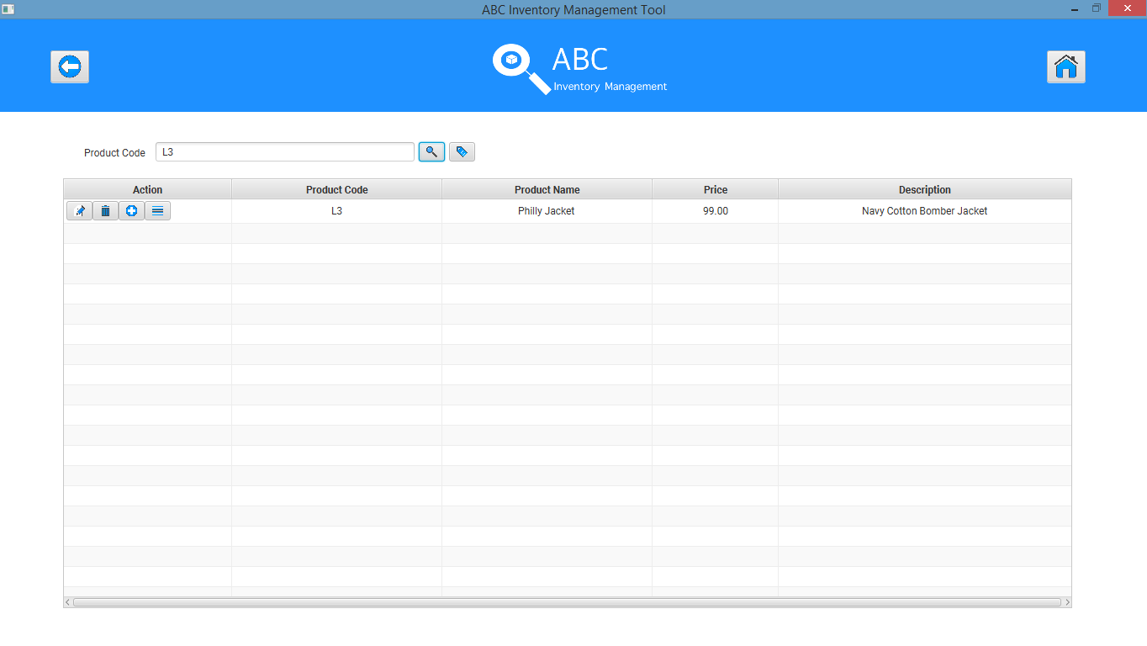

**Step 3**

Click on ‘Edit’ icon for the product ‘L3’ which needs to be updated.

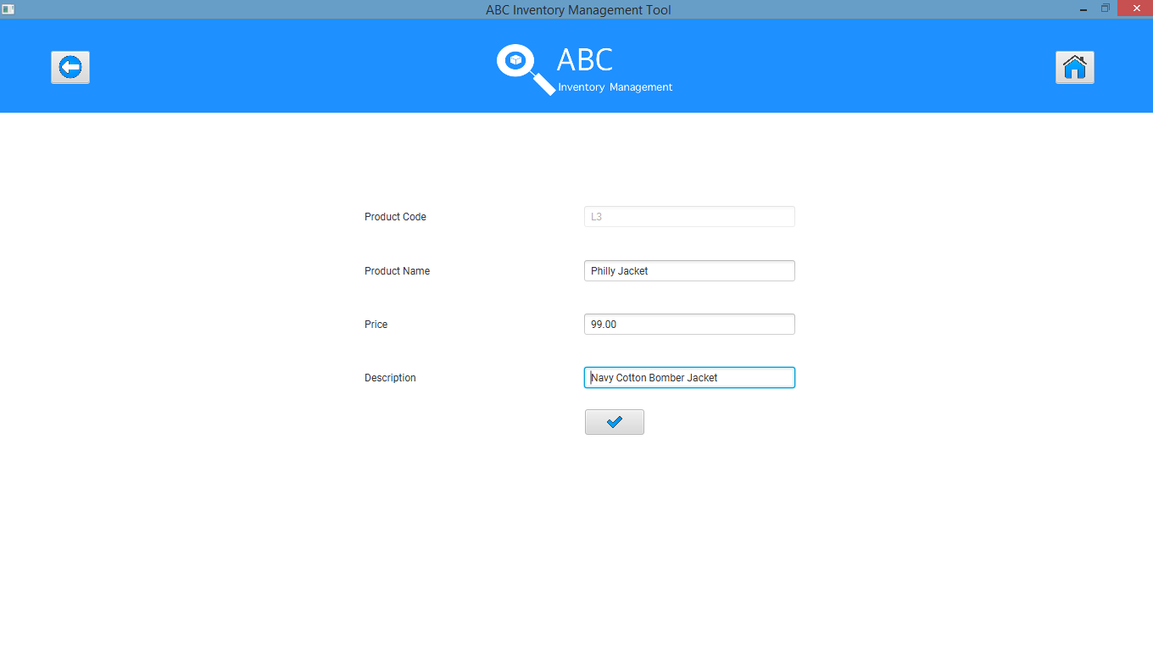

**Step 4**

Make necessary changes and click on ‘Update’ icon.

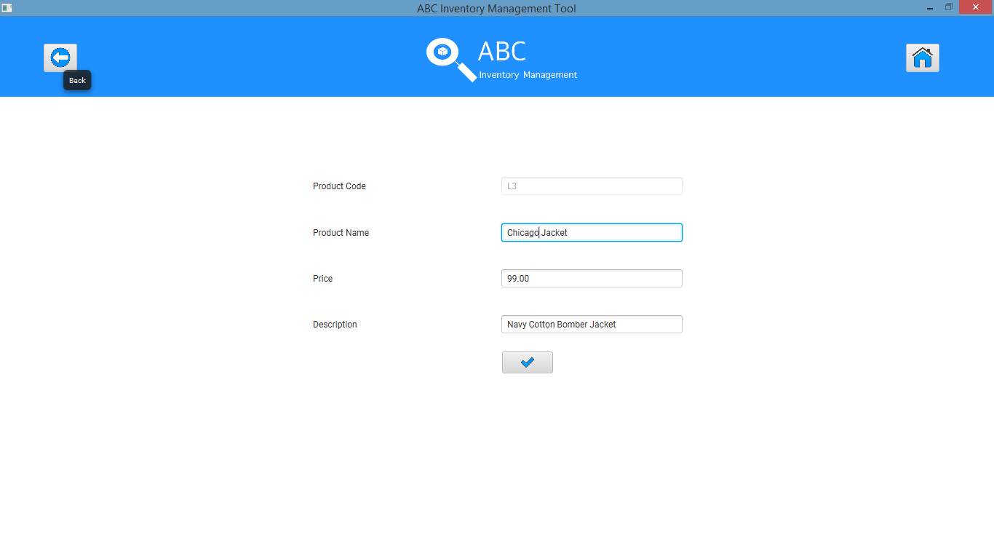

**Step 5**

System displays a message saying the product ‘L3’ has been updated.

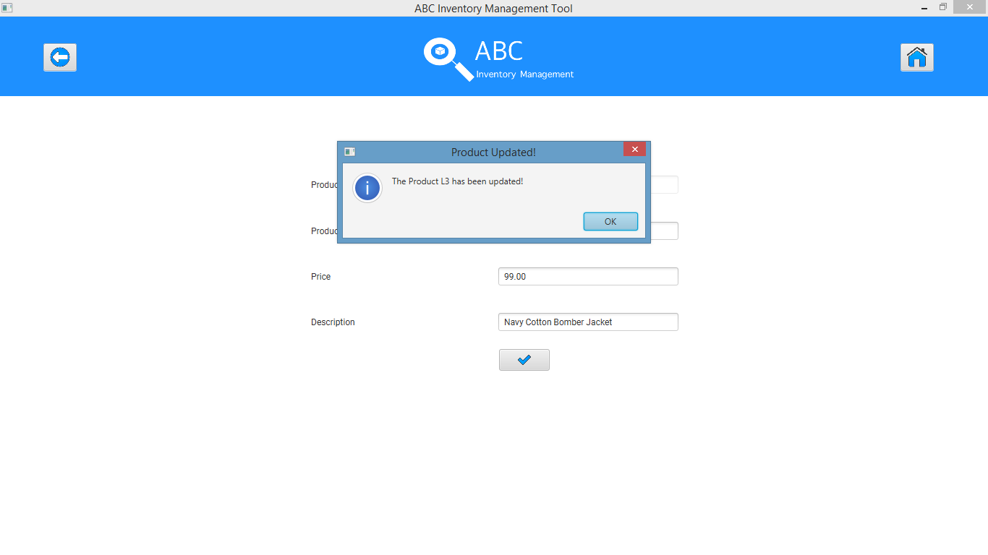

# EPQ001: Edit Product Quantity Script

## Script Description

This script follows each step while updating a product quantity in the system that was added in AP001. The script will assume that the product quantity received in WRH1 was actually 5 which needs to be updated in the system. This script will check if each step while updating the product quantity is a success. If any step fails to succeed, a bug will be reported, and the test will be conducted again.

## Testing Requirements

This test will cover the Manage Product functionality of the system.

## Setup

* The computer in the location is powered on.
* Make sure the computer is connected to the internet.
* Application is launched.
* Warehouse Staff username and password are known.
* Product that needs to be edited exists.

## Teardown

* Quantity is updated.

## Script Steps

|  |  |  |  |
| --- | --- | --- | --- |
| Step | Test Action | Expected Results | Pass/Fail |
|  | Click on ‘Manage Product’ button in homepage. | System displays the ‘Manage Product’ page and wait for user’s action. | Pass |
|  | Search for the product that needs to be edited using the product code ‘L3’ | System displays details of the product ‘L3’ | Pass |
|  | Click on ‘Details’ icon. | System displays all the sizes that exist for the product in the system. | Pass |
|  | Click on the ‘Details’ icon for the size (‘XS’) for which the quantity needs to be updated. | System displays the quantity available in each location for the size selected. | Pass |
|  | Double click on the quantity in the location that needs to be updated. | System allows user to edit the quantity. | Pass |
|  | Enter required quantity. | System waits for user’s action. | Pass |
|  | Press Enter. | System records the updated quantity in the list displayed. | Pass |
|  | Click on ‘Confirm’ icon to confirm update. | System updates the quantity in the database and displays a message saying the quantity has been updated. | Pass |

### Result Screenshots

**Step 1**

After clicking on ‘Manage Product’ at homepage.



**Step 2**

Search for the product ‘L3’ which needs to be updated using the search feature in Manage Product.



**Step 3**

Click on ‘Detail’ icon for the product ‘L3’ for which quantity needs to be updated.

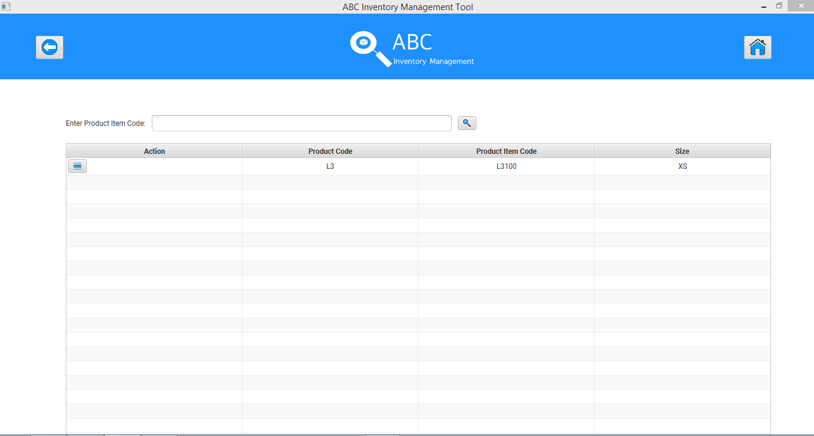

**Step 4**

Click on ‘Details’ icon for the size of the product for which the quantity needs to be updated.

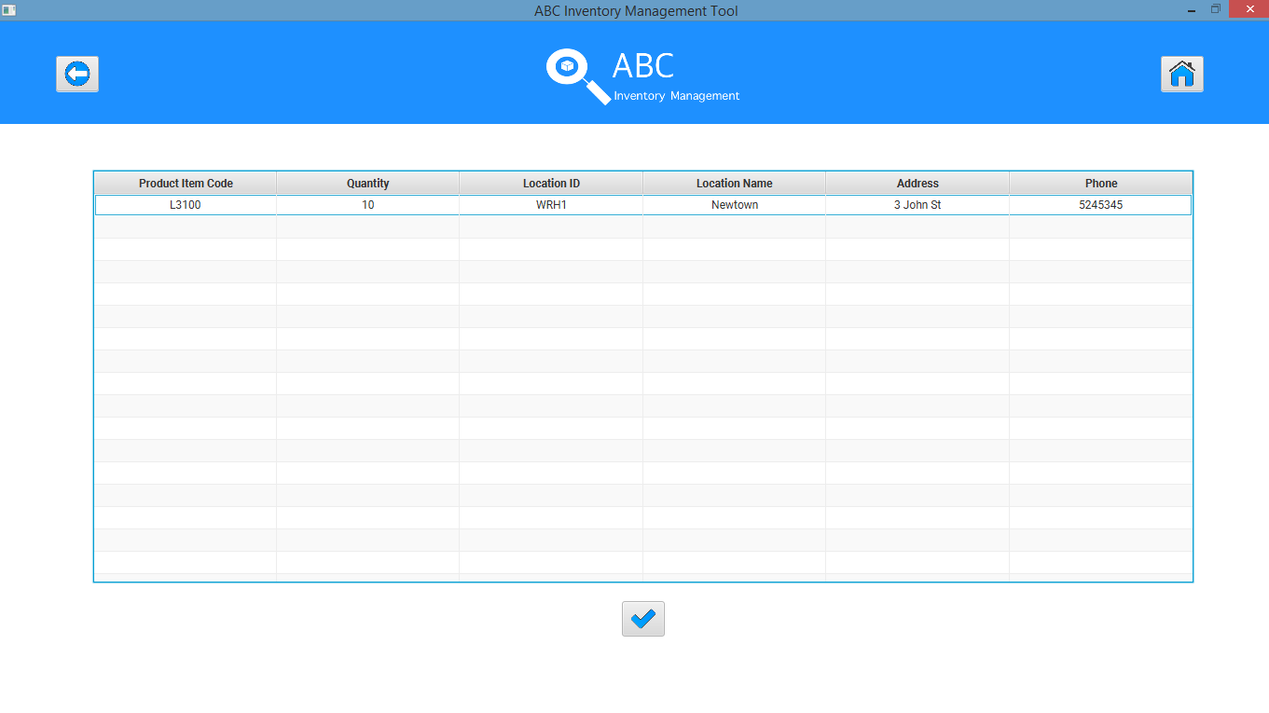

**Step 5**

Double click on the quantity of product in the location where it needs to be updated.

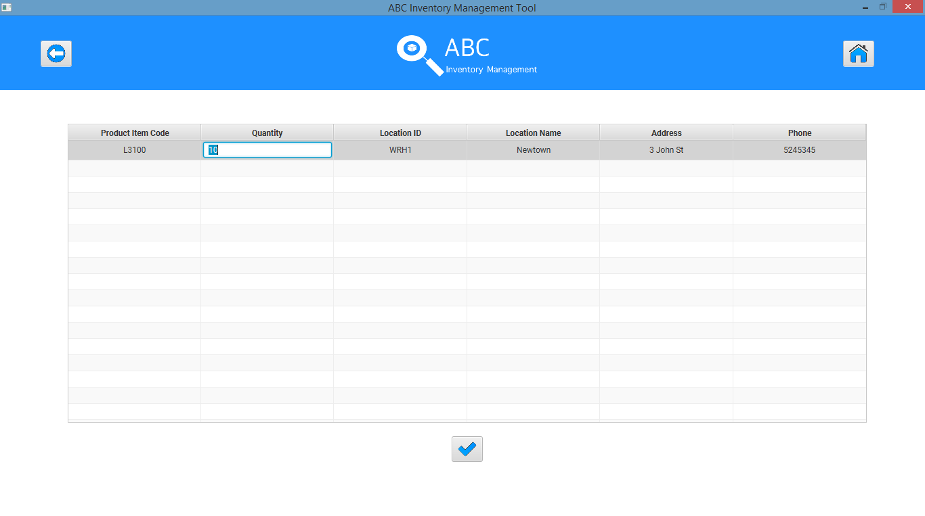

**Step 6**

Enter the required quantity.

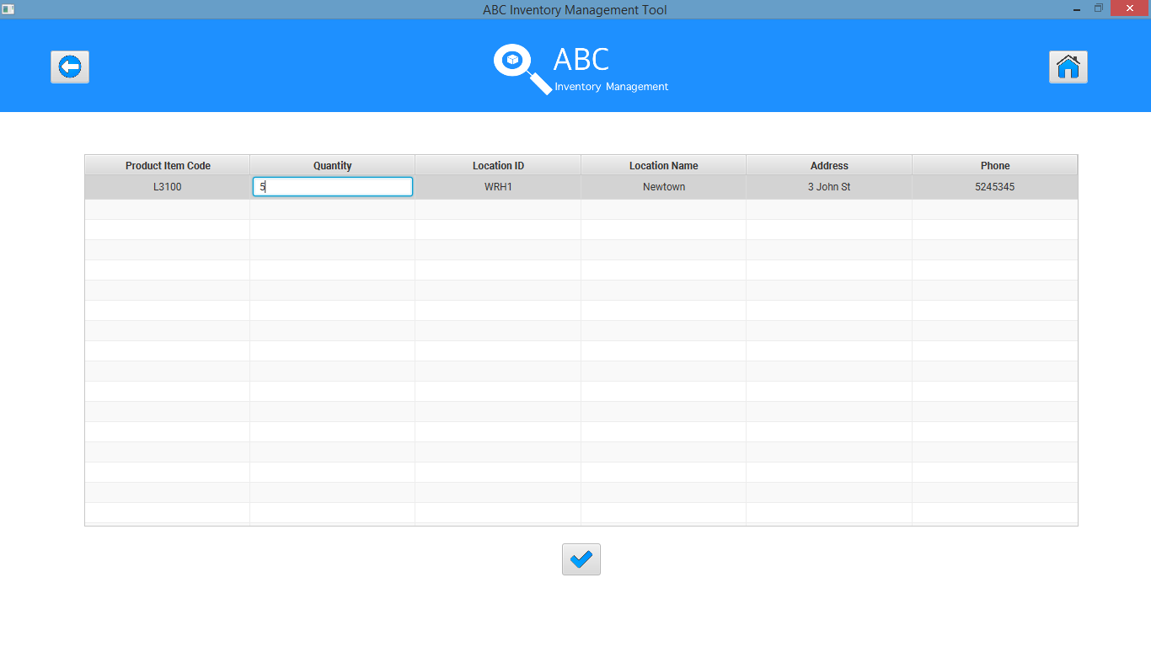

**Step 7**

Press Enter.

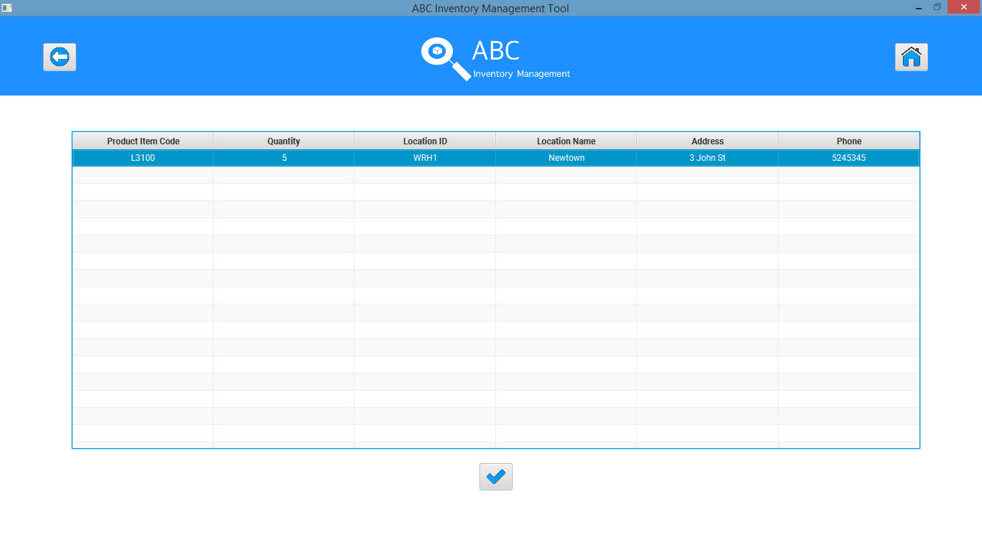

**Step 8**

Click on the ‘Confirm’ icon to confirm the quantity update.

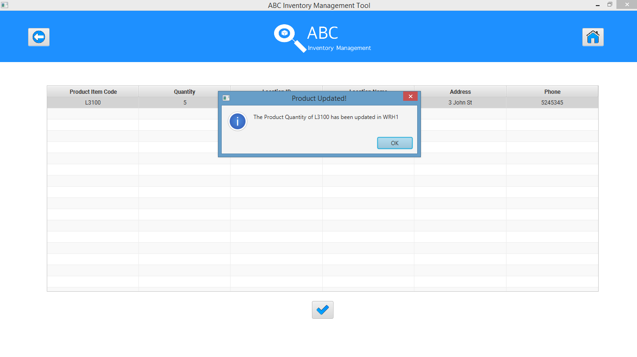

## Test Execution

|  |  |  |  |  |
| --- | --- | --- | --- | --- |
| Date/Time | Tester | Test ID | Test Phase | Status |
| 18/09/2018 | Shirish Maharjan | SM001 | Cycle 1 | Pass |
| 19/09/2018 | Shirish Maharjan | SM001 | Cycle 2 | Pass |